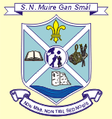
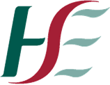
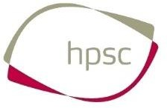

Return to Educational Facility Parental Declaration Form

Creagh National School

- Please ensure that you complete this form now for each child from Infants to Second Class who will be returning to school on March the 1st 2021.
- This form will need to be filled out for children from 3rd – 6th class in the week before they return to school (8th – 12th)
- This form will need to be filled in again when children are returning to Creagh NS after any absence.

Name of Child | Class | Teacher
Parents/Guardian’s Name:
____________________________________________________________________________

This form is to be used when children are returning to the setting after any absence.
Declarations (Please tick each one)
I have no reason to believe that my child has infectious disease and I have followed all medical and public health guidance with respect to exclusion of my child from educational facilities.
My child has not been identified as a close contact of a confirmed case.
My child has not been advised by a doctor to self-isolate at this time?
My child has not been advised to restrict their movements at this time?
My child has not engaged in foreign travel in the past 14 days.
My child is not awaiting the results of a Covid-19 test.
My child is not displaying any signs or symptoms of Covid -19.
My child is not residing with anyone who is displaying symptoms of the virus.
Signed Date: _________________________

In order to ensure the continued and safe re-opening of schools and return of pupils, it is extremely important that parents complete these forms with accuracy.

